If you use "New Report" template to create a report from scratch.
Every time selecting something from any parameters, the report will automatically refresh.
To adjust it not auto-refresh but instead using “Refresh” button inside the report manually.
Please follow below steps:
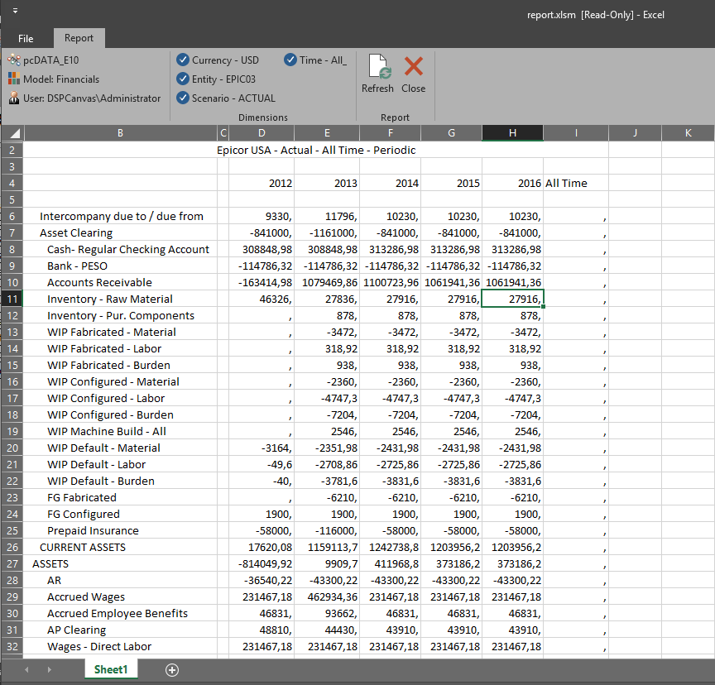

- Click on “User:xxxx” -> go to “Developer” tab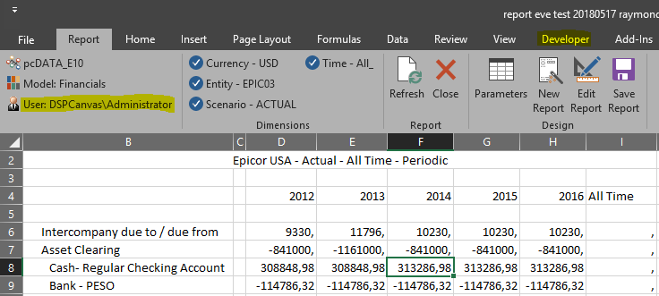
- Click on “View Code” -> double click on “Module1”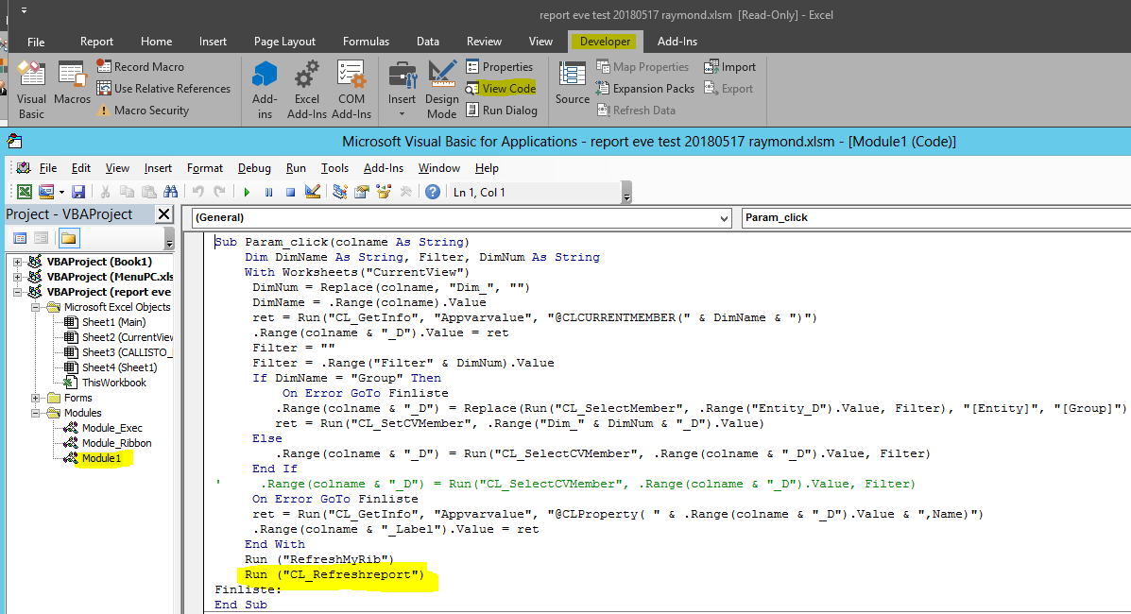
- Put ‘ in front of “Run (“CL_Refreshreport”)” row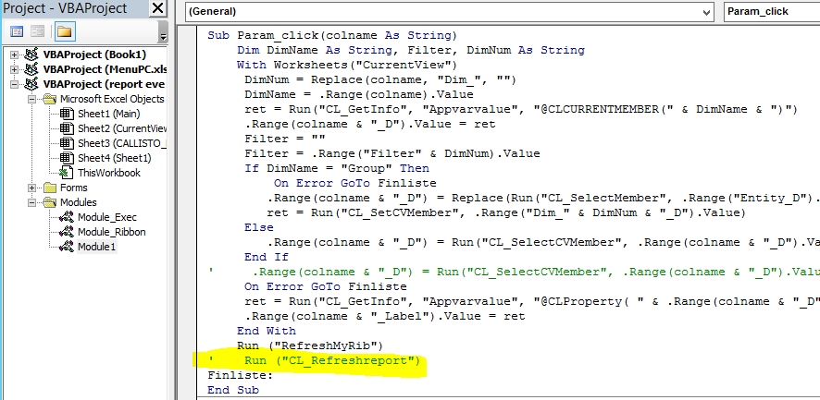
- Close the VBA and save this report in shared library or give it another name (then you have the old one and this new one).
- Open the report test, it will not refresh every time you select something from any parameters. You can only refresh report by clicking on “Refresh” button inside the report.
- You need to do the same to all your reports that you wish to do the same behaviour.

